**Section A - Plumbee Platform!**

1. **Introduction**

Plumbee is a next-generation, low-code application development platform designed to build, implement and streamline enterprise operations through smart workflows, secure architecture, and rapid deployment. Built with a focus on flexibility, automation, and user-centric design, PlumBee empowers organizations to digitize and manage complex business processes effortlessly. From robust access control to AI-assisted workflows and real-time reporting, PlumBee offers a powerful platform that adapts to diverse industry needs-ensuring agility, accountability, and efficiency at every level

**2. Plumbee platform architecture**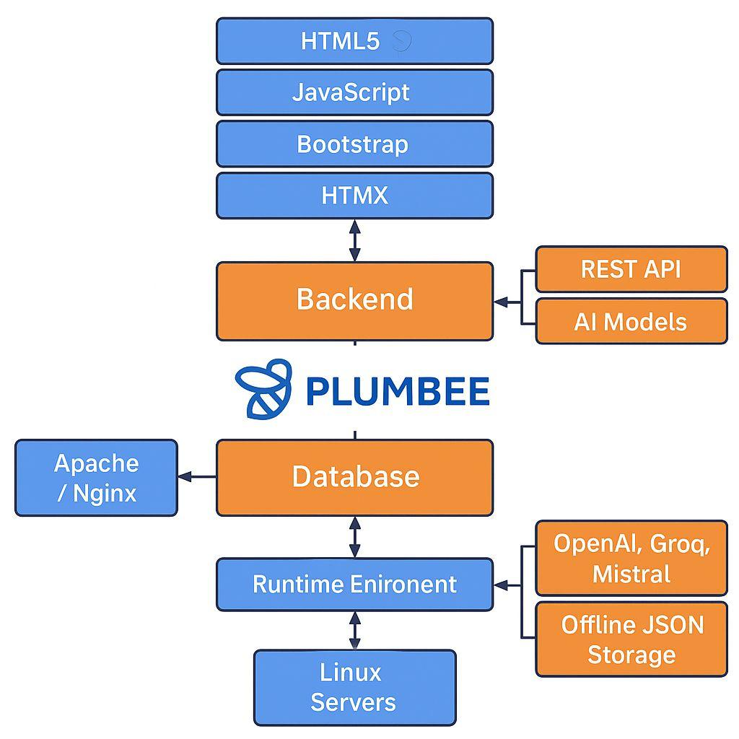

**3. Plumbee Overview**  
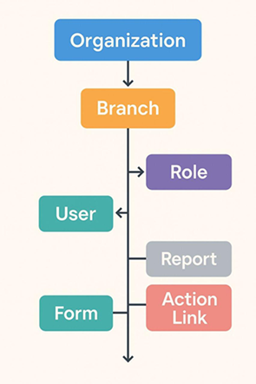

3.1. Key features

* Tabular display of form records
* Filters, sorting, and pagination
* Role-based customization
* Inline actions such as Edit, View

3.2 Advanced Capabilities

* Colour coding or bullets for status flags
* Inline editing for specific fields
* Drill-down to sub-forms
* Footer totals and summaries

3.3. Mobile Optimized Design

* Responsive layout on all devices
* Actions as icons on mobile
* Expandable row details

3.4. Security & Access Control

* Role-based visibility of data and actions
* Audit logging of key interactions
* Conditional action availability

**4. Data Capturing Controls in Plumbee platform**

4.1. Basic Input

* Text Box
* Text Area
* Dropdown (Single Select)
* Time Picker
* Dropdown (Multi Select)
* Datetime picker
* checbox Picker
* File upload

4.2. Media & Document

* File Uplaod
* Multi File Uplaod
* Photo Control
* Print Screen Button
* Signature Pad
* File upload

4.3. Data-Aware & Smart

* SQL Autofill
* Dependent Dropdown
* Calculated Field
* Recalculation
* Read-Only Label
* Server-Push Field

4.4. Checklist & Grid

* Checklist Control
* Excel Control
* Thread Control
* Stage Tag

4.5. Communication & ID

* Mobile Field
* Email Field
* PAN Field
* GST Field

4.6. Workflow & Metadata

* Mobile Field
* Email Field
* PAN Field
* GST Field

4.7. Enrichment & AI

* QR Control
* Barcode Scanner
* Run Chart Field
* URL Control
* Frame Control

4.8. Advanced

* QR Code Scanner
* Barcode Scanner
* URL Control
* Run Chart Field
* HTML Report Field

**5. Data validation in Plumbee**

5.1. Multi-level Layers

* Client-Side Validation
* Submit-Time Validation
* Server-Side Validation
* Core Engine Validation

5.2. Control-Level Validations

* Mandatory
* Read Only
* Pattern (e.g. PAN, Email)
* Date Validations
* Past Date Only
* Future Date Only
* No Future Allowed
* Format Validators
* Email, PAN, GST, Mobile
* File Upload Validation
* File size, type, extension

5.3. Example Scenarios

* Example 1 - Mandatory - ‘Leave Type’ must be filled
* Example 2 - Read Only Auto-filled ‘Employee Code’
* Example 3 - Date Validation (Past Only) ‘Birth Date’ restricted to past dates
* Example 4 - Pattern Validation PAN matched on regex

5.4. Summary

* Reduces developer effort
* Runs logic on desktop
* Data accuracy & consistency

**6. Database Management Features in PlumBEE**

6.1. Form-to-Table Synchronization

* Automatic mapping to backend tables

6.2. Auto Indexing and Key Definition

* Automated manual indexes, keys, SQL

6.3. Real-time Validation at Database Level

* Applying mandatory, numeric, date rules

6.4. Table Definition Viewer

* Shows table export and import

6.5. Secure Data Access Controls

* Role-based, and branch-level filtering

6.6. Import/Export from Excel

* Bulk data import & export, validation

6.7. Auto Archiving and Backup Configuration

* Scheduled backups & data archiving

6.8. Developer Table Locking

* System tables lockable by developers

6.9. Audit Trail and Version Control

* Recorded changes, user & timestamp

6.10. Private Tables and Isolated Views

* Restricted access for specific roles

6.11. Dynamic SQL and Custom Views

* Create reusable views using filtered datasets

6.12. Automatic Data Cleanup

* Scheduled deletion or archiving rules

**7. Developer & Debugging Features in PlumBee**

7.1. Developer-Friendly Environment Setup

* Dedicated testing & production modes
* Production changes locked with override

7.2. Database management Tools

* Auto synchronization, table viewer
* Restricted access to system tables

7.3. Intelligent Global Search Tools

* Keyword search in forms, SQL, documentation
* Auto-generate field usage reports

7.4. Testing console

* Simulate field entry, workflows
* Test user roles

7.5. Audit and Activity Trails

* Track who modified
* Audit log

7.6. Auto Help system for Developers

* ER Diagrams, Workflow visualisations
* Configuration snapshots

7.7. Intelligent warnings and alerts

* Warn for long comments, deprecated functions.
* Alerts on deployment without roles

7.8. Auto design documentation

* Fields lists, access controls, triggers
* Auto-generate from design Docs

7.9. Visual Diagram generation

* Workflow and ERD diagrams
* Dashboards diagrams

7.10. Production Environment Restrictions

* No Direct Form or Table Modifications
* Role-based access
* Read-only Designer Mode
* Data-Level Restrictions
* Logging & Audit Trails
* Limited Script execution
* No Schema changes
* Controlled Deployments
* Critical action confirmation

**8. Security features**

8.1. Security Controls

* HTTPS enforced; hyperlinks, hidden fields encrypted; dev tools tampering auto logout

8.2. User Authentication

* Optional MFA; form-specific OTP; CAPTCHA

8.3. Monitor & Log

* Full audit trail; developer change logs; malicious alerts

8.4. Integrity protection

* No backdated entries; version controlled documents; post-state lock

8.5. Logic validation

* Server-side validations; logical consistency checks; conditional restrictions

8.6. Access Governance

* Role-based access; branch/location restrictions; secure external links

8.7. Unique Identifier

* Each request is assigned a unique ID

8.8. Random number generation

* Random number assigned with each submit

8.9. Access Control

* Configures access rights for users and roles

8.10. Audit logging

* Logging of all inserts, updates, and deletes

8.11. CAPTHA Verification

* CAPTCHA included on login and submit screens

**9. Types of workflow in Plumbee platform**

9.1. Standard Multi-Stage Workflow

* Used in Vendor bill approval; stages are entry  Verify  Post

9.2. Role-based Dynamic Workflow

* Used in capital expenditure

9.3. Matrix workflow (Role – Branch)

* Used in multi-branch leave application, approver determined by branch form

9.4. Recurring workflow

* Used in daily machine checklist, resets daily for operators

9.5. Easy flow Visual Workflow

* Used in employee onboarding stages are Entry  Verify  Approve  Post

9.6. Attachment-Based workflow

* Used in employee reimbursement workflow required specific supporting receipts

9.7. External Approval workflow

* Used in resume-feedback from college mentor; external reviewer invited by email

**9.8. AI-Triggered workflow**

* Used in RFP analysis; GPT highlights key term and routes if penalty applicable.  TL/Day

9.9. Escalation workflow

* Used in customer complaints; if delayed beyond (hold, escalated to service head)

9.10. Parallel workflow

* Used in protect approval, legal, technical) and commercial roles approve in parallel.

9.11. Commonly-only Workflow

* Used in internal requests stakeholders add remarks or observations

9.12. OTP-Protected workflow stage.

* Used in final salary approval; posting required CITP via SMS to complete

**10. Reporting Features in Plumbee**

10.1. Types of reports

* Standard
* Listing
* Dynamic
* Dashboard
* Scheduler
* Charts

10.2. Drill-down and linked reports

* Column selection custom filters
* Group-by & aggregates
* Save as template
* Export or Schedule

10.3. Scheduled Reports

* Custom timing (Daily, weekly, monthly)
* Delivery via email, message, FTP
* Includes charges, KPIs

10.4. Mobile access & command based reporting

* Bar, Line, Pie, Area, Adhoc, Funnel
* Drill-down dashboards
* Conditional colouring

10.5. Unique reporting features

* AI generated summaries
* On-click approval/rejection
* Drill-through data views
* Custom access control
* Inline filtering, surfing, export chart reports with toggles.

10.6. Real-Life scenarios Using plumBee reports

* Daily sales report on Whatsapp
* Regional manager need daily sales figures.
* Scheduled report runs at 6:00 pm
* Auto-sent to Whatsapp with summary charts
* Manager can text Sales today for live status

10.7. Dynamic procurement dashboard

* Monthly procurement review
* Dynamic report shows ordered report shows order vs, received
* Displays vendor delay summary
* Drill-down links open PO Forms

10.8. Employee Tree view for HR

* HR Reviews a transfer candidate
* HR Clicks employee row in report
* Opens child tabs, family, education, attendance
* One-stop structure review

10.9. Finance Audit report

* Auditor needs expense summary
* Register report lists call claims
* Each row links to scanned bills and approvals
* Auditor approves inline or flags issues

**11. Navigation in PlumBee**

11.1. Main Navigation areas

* Top global bar, for user, role, od notifications
* Collapsible left side min for forms, reports, actions
* Only permitted forms logged-in role are shown

11.2. Navigation Methods

* Click-based navigation
* Gesture support on mobile
* Global search bar quick access

11.3. Structure of Navigation Entities

* Label and icon
* Link type & Access role
* Display condition & action on click

11.4. Role-Based Form Access

* Only permitted forms list – shown
* Opens child forms
* Opens child forms

11.5. Special Navigation Features

* Quick access panel
* Floating search shortcuts
* Breadcrumb trail

11.6. Navigation Between Linked Forms

* Open child forms, in panels
* Parent environment
* Slickable charts with filters

11.7. Mobile Optimizations

* Menu collapses automatically
* Uses mobile keyboards, camera
* GeoTagging, WhatsApp protected

11.8. Security in Navigation

* Menu clicks are secure events
* Assign icons, filters, tags
* Preload filters in reports tabs

**Section B – Enterprise Solutions**

**Real-World ERP Implementation**

12.1. Customer Segments

* Education
* IIT Jammu
* IIT Tirupati
* IIIT Hyderabad
* MNIT Jaipur
* NSUT Delhi

12.2. Logistics & Fleet

* PBL Transport
* IRSM

12.3. Law & International

* Mundiex (USA)
* Simple Law (USA)

12.4. Manufacturing

* Deevyashakti Papers, Orient Cements
* Asahi Glass
* Windshield Experts

12.5. Banking

* Karnataka Bank
* Corporation Bank
* Andhra Bank

12.6. Media

* Reliance Broadcasting Network

12.7. ERP Modules Implemented

* Setup & Configuration
* Multi-organization branch setup
* Access rights, document series

12.8. Sales & CRM

* Shopping cart, leads, quotations
* Sales orders, customer dashboard

12.9. Production

* Production logs, equipment, breakdown and maintenance

12.10. Projects

* Task assignment, expense vs income comparison, location lagging

12.11. Finance

* Cheque management, bank reconciliation, TDS / GST

12.12. Unique Functionalities

* Mobile-Only Access  
  o Field engineers fill forms from WhatsApp
* WhatsApp / Telegram Integration  
  o Command-based reports, approvals  
  o Instant document preview links
* Offline Field Operations  
  o Offline JSON form submission  
  o Photos, notes, location
* RFP and Resume AI  
  o Auto-summarizes EMD, scored MCQs  
  o QR, Barcode, UPI Image Reading

**12.13. Practical Workflows**

* Purchase Flow (with Approvals)  
  o Indent approval on WhatsApp  
  o Auto quotation comparison  
  o PO, GRN, payment
* Education Process  
  o Online admission form  
  o Auto fee generation
* Logistics  
  o Vehicle assignment via Telegram  
  o Checklist, GPS check-in, delivery
* AI-Driven Resume Evaluation  
  o Resume upload  
  o Extracted skills, scored MCQs

12.14. Administrative Controls

* Audit Trails
* OTP Approval
* Branch Permissions
* Developer’s Logs

**13. Education Modules in Plumbee platform**

13.1. Institution Setup & Branch Configuration

* Configure systems structure

13.2. Academic Timetable

* Assign to calendar

13.3. Leave Application

* Issues faculty uploads, solutions via deadline

13.4. Student Admission Management

* Online application

13.5. Class Attendance

* Unlocks student schedule

13.6. Library Management

* Issues test schedule, VABs

13.7. Student Master

* Online application via documents

13.8. Assignment & Submission Tracker

* Status, teaching solutions

13.9. Complaint/Feedback

* Shows teaching load, dues, remarks

13.10. Course & Subject Management

* Define provided dues

13.11. Exam Scheduling & Hall Ticket

* Exam scheduling & hall ticket

13.12. Student Progress Card

* Disciplinary action log

13.13. Fee Structure Definition

* Schools, prior to ratio charting

13.14. Student ID Card Generation

* Hostel management

13.15. Placement & Training Tracker

* Project & Thesis submission

13.16. Scholarship Assignment

* Implements as required

13.17. Hostel Management

* Define hostels, floors

13.18. Notice Board Management

* Academic calendar

13.19. Grading Criteria Support

* Evaluation rubric documentation

13.20. Complaint/Feedback

* Presenting assignments

13.21. Certificate Request

* Certificate request

13.22. Academic Timetable

* Assign via regulations

13.23. Student Progress Card

* Student progress card

13.24. Alumni Management

* WhatsApp integration

13.25. Student Progress Card

* Disciplinary action log

13.26. MCQ Generator from Syllabus

* AI extracts topics and TPA

13.27. Face Recognition Attendance

* MCQ generator from syllabus

13.28. Student Activity Tracker

* Placement & tracker

13.29. Auto Documentation for Teachers

* Class log, syllabus pane

**14. Commercial Model**

14.1. CRM

* Lead Management
* Opportunity Pipeline
* Account Management
* Communication Tracking
* Campaign Management

14.2. PURCHASE

* Indent & Requisition
* Purchase Indent Approval
* Request for Quotation (RFQ)
* Online Vendor Quotation Submissions (Bid)
* Vendor Quote Comparison
* Purchase Order
* Service Work Order
* Purchase Order Approval
* Purchase Order Amendment
* Goods Receipt Note
* Purchase Returns
* Mange old Orders
* Purchase JV
* Document Attachments
* Purchase Reports

14.2.1. SALES

* Sales Quotations
* Sales Orders
* Sales Order Approval
* Delivery Challans
* Sales Invoices
* Sales Returns
* Stock Transfers
* Stock for Sales
* Manage old Orders
* Sales Persons
* Sales Targets
* Sales JV
* Document Attachments
* Sales Reports
* Dashboards

14.3. INVENTORY

* Stores Issue Indent
* Stores Issues
* Material Returns
* Stock In/Out (Inter Branch)
* Job Order In/out
* Stores Valuation
* Stocks & Stock Reports
* Put away Process (Stock Reservations)
* Consumption JV (Subject to finance module)
* Warehouse Bin Definition

14.4.FINANCE

* Chart of Accounts
* Voucher System
* Bank Integration
* Cash & Fund Flow Reports
* TDS, GST & Tax Compliance
* Balance sheet Schedules – VI
* Chart of Accounts
* Cost Centers
* Budgets
* General Ledger GL
* Bank transactions
* Cash Transactions
* Dr / Credit Notes
* Journal Vouchers
* Accounts Receivables
* Accounts Payables
* Contra – funds transfer
* Account Setoffs
* TDS
* Simple Bank Reconciliation
* TDS Form Tracking
* Inter Branch Vouchers
* Finance Reports (TB, P & L, and Balance Sheet etc.)
* Dashboards

14.5.PRODUCTION

* Bill of Materials
* Work Orders
* Process Routing
* WIP Tracking
* Material Requirement Planning (MRP)
* Production Planning
* Production Scheduling (Excl machine scheduling)
* JOB Card
* Production Log
* Adjustments
* Reports
* Batch Tracking
* Dashboard

14.6.FIXED ASSETS

* Masters – Fixed Asset Groups
* FA GRNs
* Capitalization
* Fixed Asset Register
* Asset Movement
* Depreciation (IT Law/ Company Law)
* Reports

14.7. PLANT MAINTENANCE

* Masters - Machinery
* Machine Details
* Machine Utilization
* Machinery Movement
* Insurance Details
* Maintenance History
* Preventive Maintenance
* Work done
* Asset Repair Details (WBS)
* Expenditure details

14.8. QUALITY CONTROL

* Masters - Machinery
* Machine Details
* Machine Utilization
* Machinery Movement
* Insurance Details
* Maintenance History
* Preventive Maintenance
* Work done
* Asset Repair Details (WBS)
* Expenditure details

14.9. OFFICE MANAGEMENT

* Task management
* Ticketing management
* Workflow
* Meetings management
* Alerts & Notifications

14.10. DOCUMENT MANAGEMENT

* Centralized Document Repository
* Upload, Attach & Capture
* Version Management
* Security & Access Control
* Intelligent Search & Retrieval
* Integration with Workflow & Approvals
* Mobile & Remote Accessibility